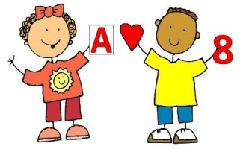

I am in preschool.
I was not built to sit still,
Keep my hands to myself,
Take turns,
Be patient,
Stand in line,
Or keep quiet
All of the time.

I need:
Motion,
Novelty,
Adventure
And to engage the world with my whole body!

Let me play.
(Trust me, I’m learning!)

